ENGR 200 FALL, 2017

**A1: LINEAR INTERPOLATION**

**(basic program development)**

DUE: Sept. 5, 2017 by 11:59 pm, CDT POINTS: 35

**INTRODUCTION:**

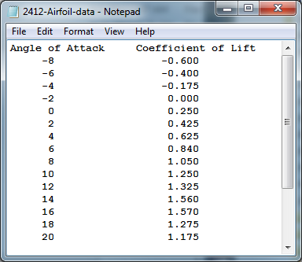Linear interpolation is a simple mathematical method to calculate intermediate values between known data points along a straight line providing that the data points are relatively close to minimize error. This type of interpolation can be affectively applied to tables of values, and allows the calculation of intermediate values that are not part of the original data set. Such a table of test data is illustrated to the right indicating **Angles of Attack** in degrees and corresponding **Coefficients of Lift**.

The data has been experimentally collected for a NACA 2412 airfoil from the wing section graph. The 2412 is the primary airfoil used by Cessna for decades on the C172 production line.

To calculate an intermediate coefficient of lift data point you would use the following equation:

$$\frac{computed_coefficient_lift-coefficient_lift1}{interpolate_angle-angle1}=\frac{coefficient_lift2-coefficient_lift1}{angle2-angle1}$$

NOTE: You will need to solve the above expression for the **computed coefficient of lift** variable and use that algebraic expression in your program.

******************************************

LINEAR INTERPOLATION PROGRAM

Enter first angle in degrees : x

Enter first coefficient of lift : x

Enter second angle in degrees : x

Enter second coefficient of lift : x

Enter interpolation angle in degrees: x

RESULTS

First angle in degrees = xx.xxx

First coefficient of lift = xx.xxx

Second angle in degrees = xx.xxx

Second coefficient of lift = xx.xxx

Interpolation angle in degrees = xx.xxx

Computed coefficient of lift = xx.xxx

******************************************

**ASSIGNMENT:**

Write a C program that will allow the user to enter two known **Angles of Attack** and their corresponding known **Coefficients of Lift** values. Once the user enters the interpolation angle, the program will compute the intermediate **Coefficient of Lift**. Your input/output will look like the illustration shown to the right.

**SUBMITTING ASSIGNMENT:**

Once you have your program working and saved, exit the C compiler that you are using. Make sure that your source program file name conforms to the following specifications:

***sn_an_first_last***

where: ***sn*** is your section number ( 2, 4, 6, 7)

***an*** is the assignment number (1, 2, 3, 4, 5, 6, …)

***first*** is your first name

***last*** is your last name

An example file name for the first assignment is **1_1_elmer_fudd**. Always use the underscore character in the file name. Do not use spaces in the file name.

**Note: Do not** change the extension, **.cpp,** that is at the end of the file name.

Submit your assignment (your source program) using the **Assignments** button in **Blackboard**. The submitting instructions are provided in several locations in **Blackboard**, so read them carefully. Remember to submit your C source program only. No other program format will be accepted.

If you make changes to your program and need to resubmit, rename the file such as **1_1_elmer_fudd_2** or **1_1_elmer_fudd_3**, etc. Then use the **Assignments** button in **Blackboard** to submit the new version. Only the most current submitted program version will be graded.